ISS method

The infinitely sharp split method (ISS) is a simplified mass balance over the extractive section. The following assumption are made:
- Each column section is of infinite height.
One of the azeotropic pair is absent in the entrainer feeding tray and the bottom tray
- Constant molar flow rates
The extractive columns and distribution of species can be seen in Figure 1.
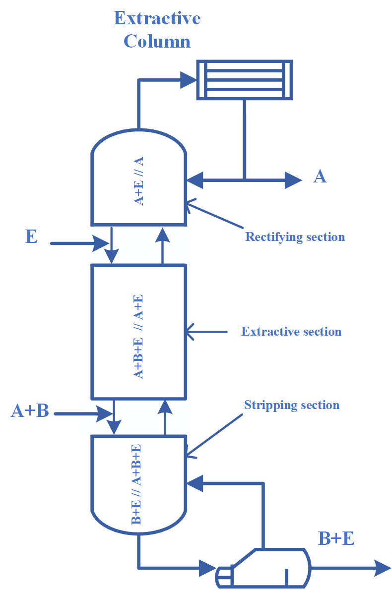
Figure 1: Distribution of species in the different sections of the extractive column

If we consider the rectifying section, as seen below:
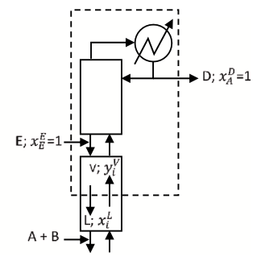

At the top we have (pure distillate assumption)
$$x_{A}^{D}=1, x_{B}^{D}=0, x_{E}^{D}=0$$
At the feeding stage of the entrainer (pure entrainer assumption)
$$x_{A}^{E}=0, x_{B}^{E}=0, x_{E}^{E}=1$$
Mass balance of B – the absent compound on the edge A-E
$$V*K_{B}^{r}*x_{B}^{r}=L*x_{B}^{r}-E*x_{B}^{E}$$
$$⇓$$
$$V*K_{B}^{r}*x_{B}^{r}=L*x_{B}^{r}$$
$$⇓$$
$$\frac{L}{V}=K_{B}^{r}$$
Mass balance of A – to compute the delta point $x_{A}^{Δ}$ being the difference between the entrainer feeding and the distillate product
$$Δ=D-E$$
$$\left(D-E\right)*x_{A}^{Δ}=D*x_{A}^{D}-E*x_{A}^{E}$$
$$⇓$$
$$\frac{D-E}{D}*x_{A}^{Δ}=1$$
$$⇓$$
$$\frac{E}{D}=1-\frac{1}{x_{A}^{Δ}}$$
$$⇓$$
$$\frac{E}{D}=\frac{x_{A}^{Δ}-1}{x_{A}^{Δ}}$$

Mass balance of A – at the root point $x_{A}^{r}$ on the edge AE to set a relationship between $x_{A}^{r}$ and $x_{A}^{Δ}$
$$V*K_{A}^{r}*x_{A}^{r}=L*x_{A}^{r}+D*x_{A}^{D}-E*x_{A}^{E}$$
$$⇓$$
$$V*K_{A}^{r}*x_{A}^{r}=L*x_{A}^{r}+\left(D-E\right)*x_{A}^{Δ}$$
$$⇓$$
$$x_{A}^{Δ}=\frac{V*K_{A}^{r}-L}{D-E}$$
$$⇓$$
$$x_{A}^{Δ}=\frac{\frac{V}{V}*K_{A}^{r}-\frac{L}{V}}{\frac{D}{V}-\frac{E}{V}}*x_{A}^{r}$$
$$⇓$$
$$x_{A}^{Δ}=\frac{K_{A}^{r}-K_{B}^{r}}{\frac{D-E}{V}}*x_{A}^{r}$$
$$⇓$$
$$x_{A}^{Δ}=\frac{K_{A}^{r}-K_{B}^{r}}{\frac{V-L}{V}}*x_{A}^{r}$$
$$⇓$$
$$x_{A}^{Δ}=\frac{K_{A}^{r}-K_{B}^{r}}{1-K_{B}^{r}}*x_{A}^{r}$$
Relationship between (L/V)_{TOP} at the rectifying section with (L/V)=K^{r}_{B} computed for the extractive section

$${\left(\frac{L}{V}\right)}_{TOP}=\frac{K_{B}^{r}-E/D}{1-E/D}$$

We can also combine the two equations below
$$\frac{E}{D}=\frac{x_{A}^{Δ}-1}{x_{A}^{Δ}}$$ | $$x_{A}^{Δ}=\frac{K_{A}^{r}-K_{B}^{r}}{1-K_{B}^{r}}*x_{A}^{r}$$
To obtain
$$\frac{E}{D}=1-\frac{1}{x_{A}^{Δ}}$$
$$⇓$$
$$\frac{E}{D}=1-\frac{1-K_{B}^{r}}{x_{A}^{r}*\left(K_{A}^{r}-K_{B}^{r}\right)}$$
The optimization routine is as follows:
$$\min{1-\frac{1-K_{B}^{r}}{x_{A}^{r}*\left(K_{A}^{r}-K_{B}^{r}\right)}}$$
With
$$0<x_{A}^{r}<x_{A}^{(α_{A,B}=1,x_{B}=0)}$$

So, we first need to find on AE edge the composition of A for which the relative volatility $α_{A,B}=1$, while xB=0.
The minimum reflux can be calculated by using the minimal E/D
$${{\left(\frac{L}{V}\right)}^{min}}_{TOP}=\frac{K_{B}^{r}-{\left(\frac{E}{D}\right)}_{min}}{1-{\left(\frac{E}{D}\right)}_{min}}$$

